Installation Steps:
Before installing application you need to fill prerequisite for the application.

Server Installation:
- You need WAMP server in order to make your system as “localhost”
- Run “Wamp server” from Start -> All Programs -> Wamp Server
- Wamp server will available in tray icon. Please find screenshot below:
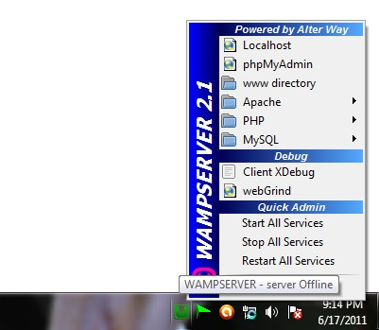

Database Setup:
- Click “PhpMyAdmin” from wamp server by click tray server icon.
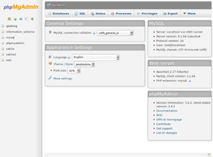
- Create Database -> name as “xyz” -> click ok
- After creating database, import the sql named as “database.sql” which will available in “Database” folder.

Application Installation:
- After installation, open the “www” folder from the tray icon.
- Paste all the files from the “xyz” folder into “www” folder.
- Now installation done!!!
Run Application:
- Open browser (Internet explorer / firefox / chrome), type “localhost” in the address bar if the installation done in the same system, otherwise type the URL of the server in which the application is installed.
- Enter login details to enter into application
- Admin Login credentials
  - Username : admin
  - Password : password

- One of the Customer login
  - Username : user1@tcs.com
  - Password : password

- You’re Done!!!

